**BUILDING A FACE DETECTION APP ON AWS**

Architecture:

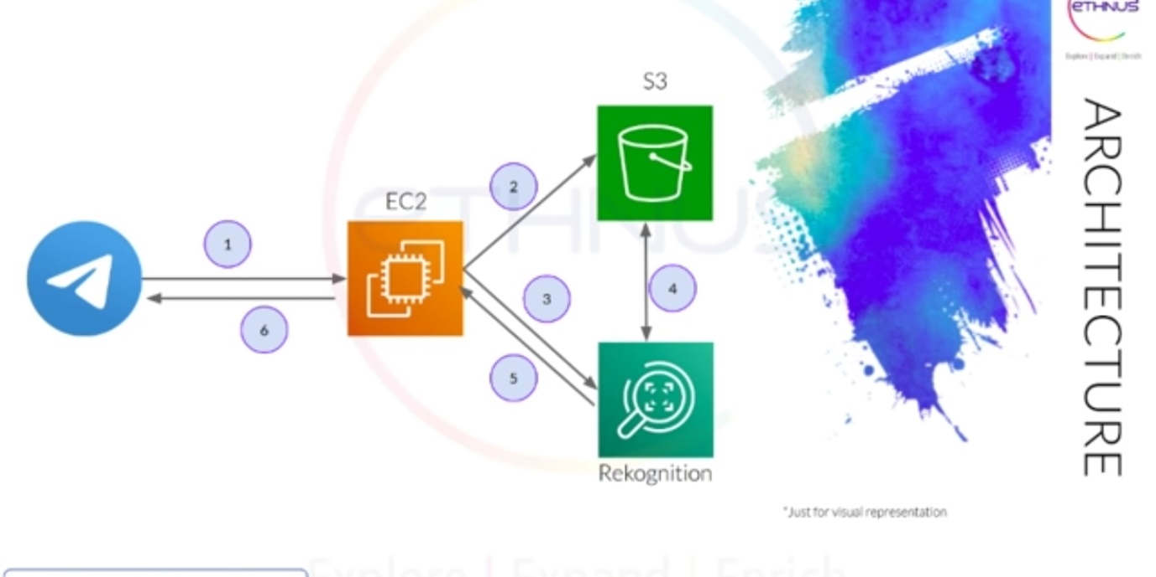

Dashboards:

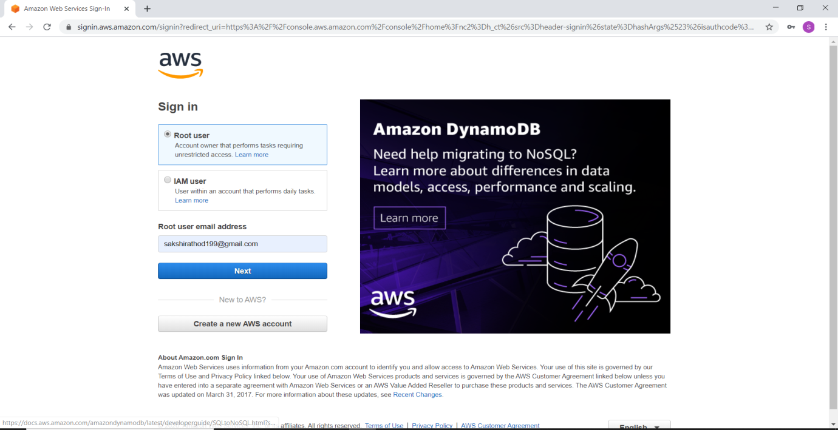

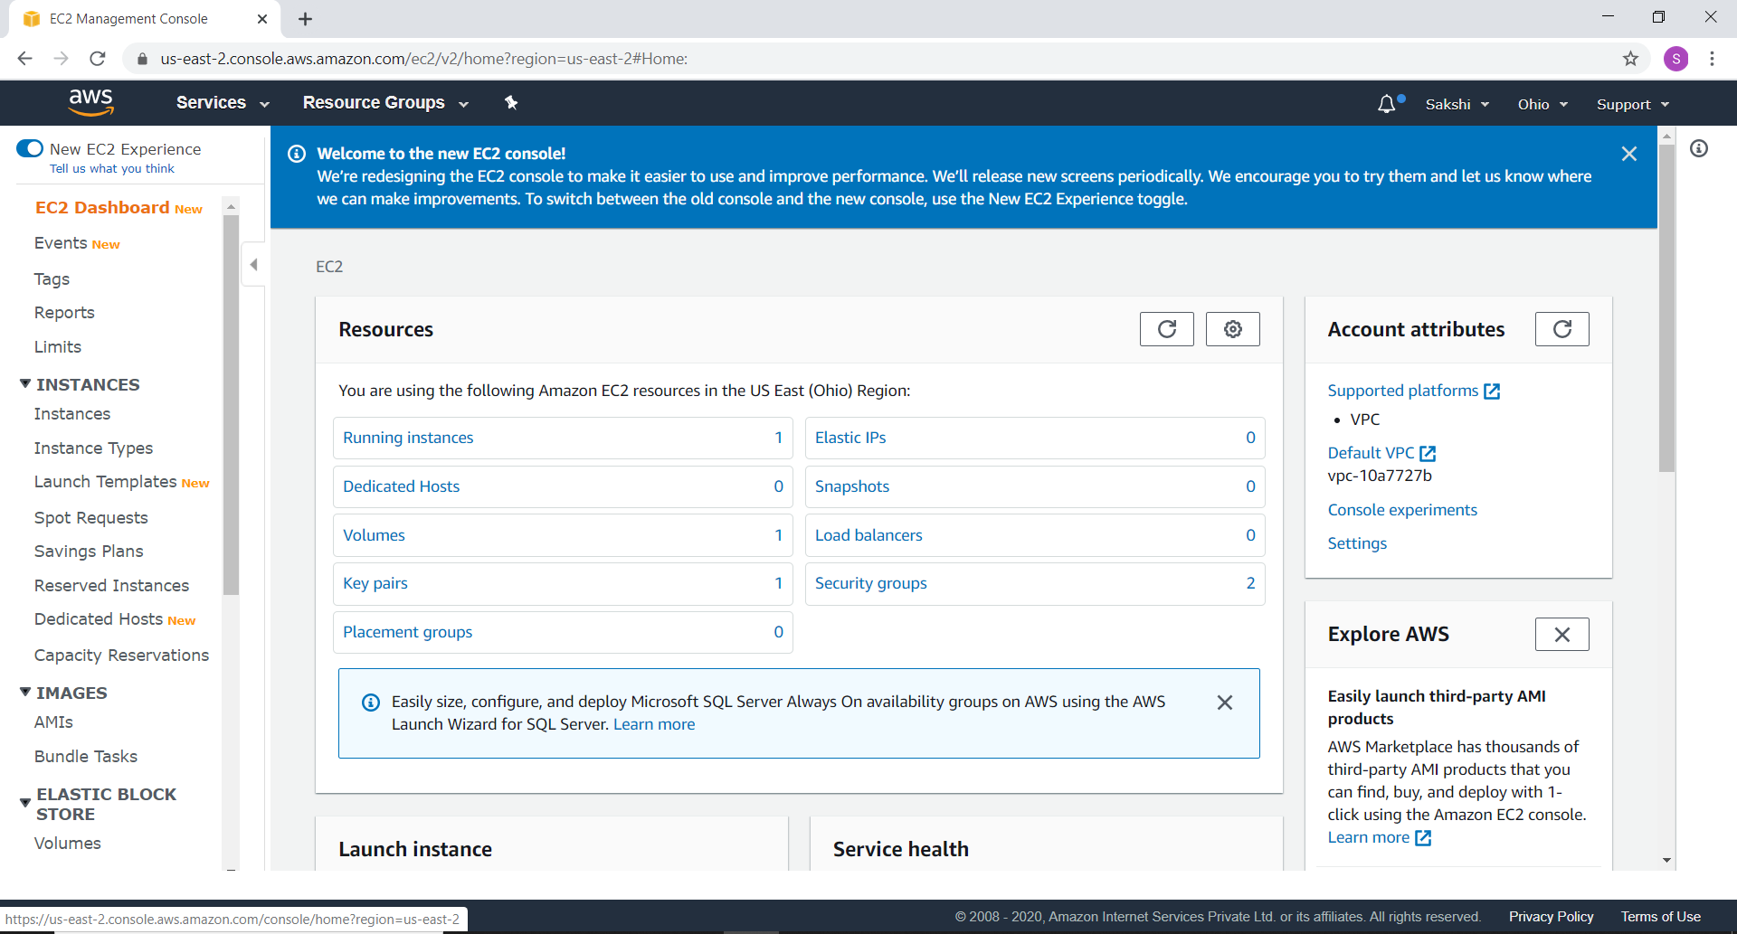

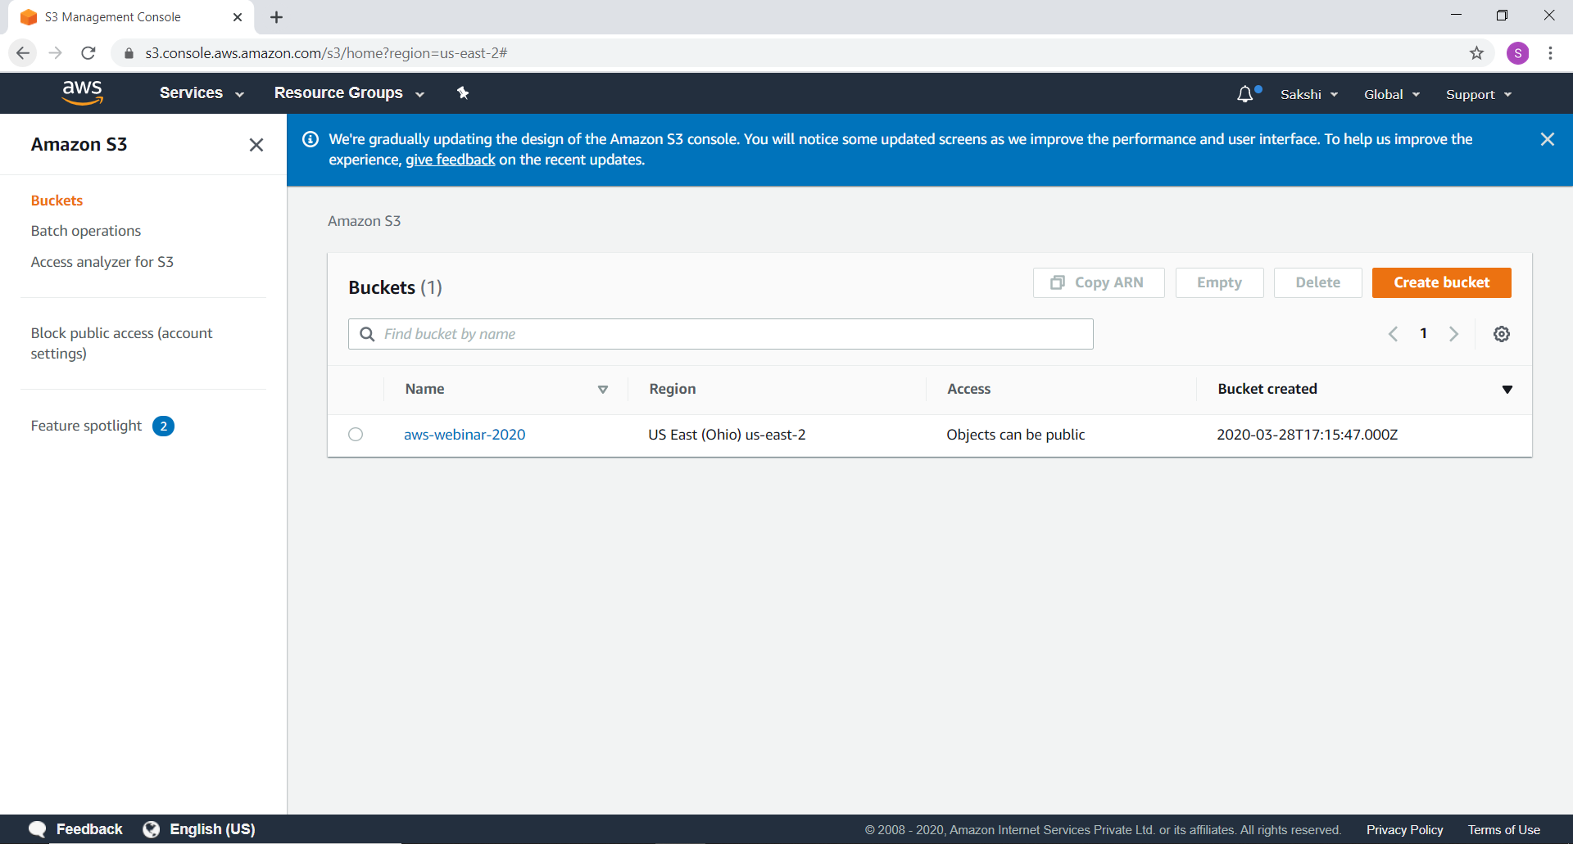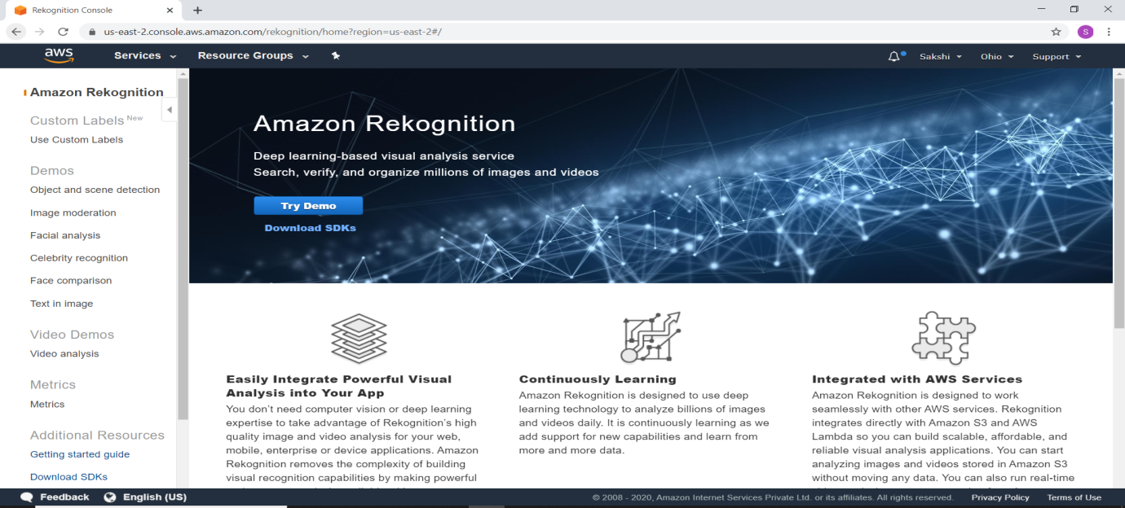

**EC2:**

Steps involved in creating EC2:

* Operating System (Amazon Linux 2 AMI)
* Instance type: t2 micro
* Ram & Processor
* Storage (8 GB is enough)
* Security(type: SSH ; port: 22)

Let’s launch an instance:

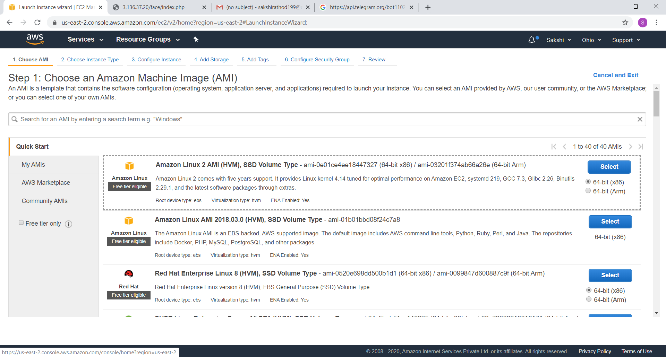

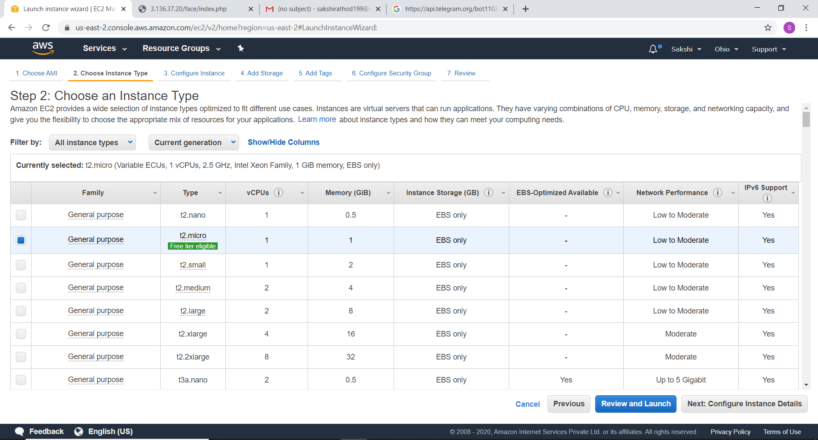

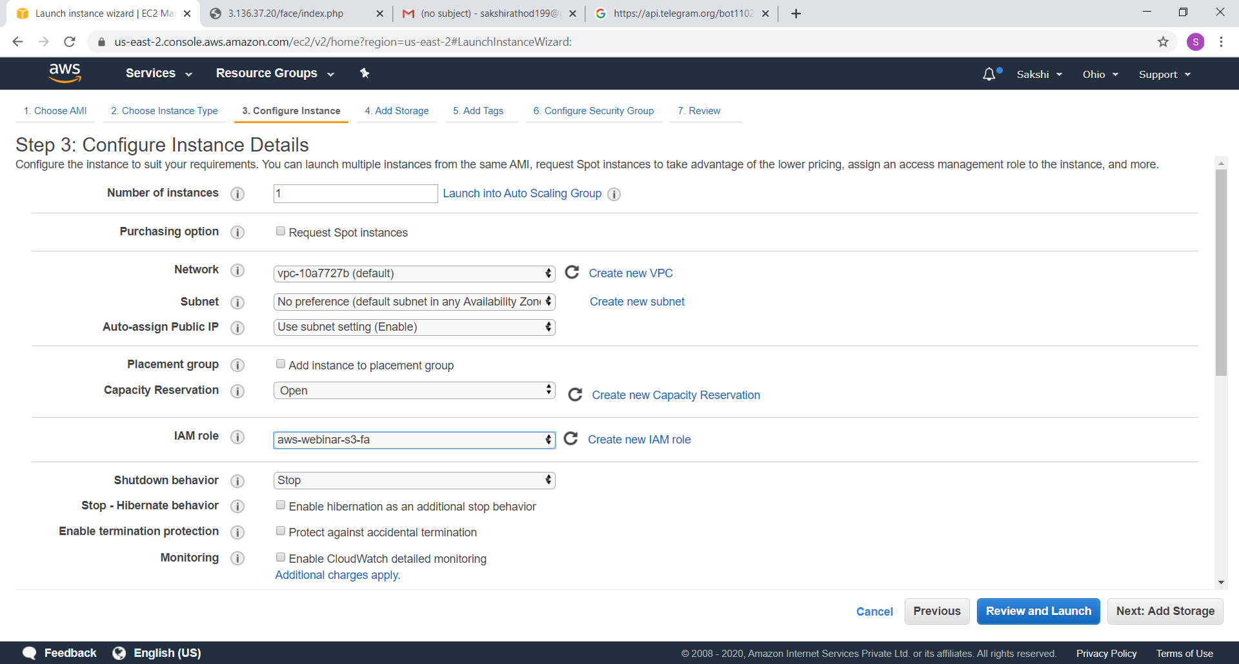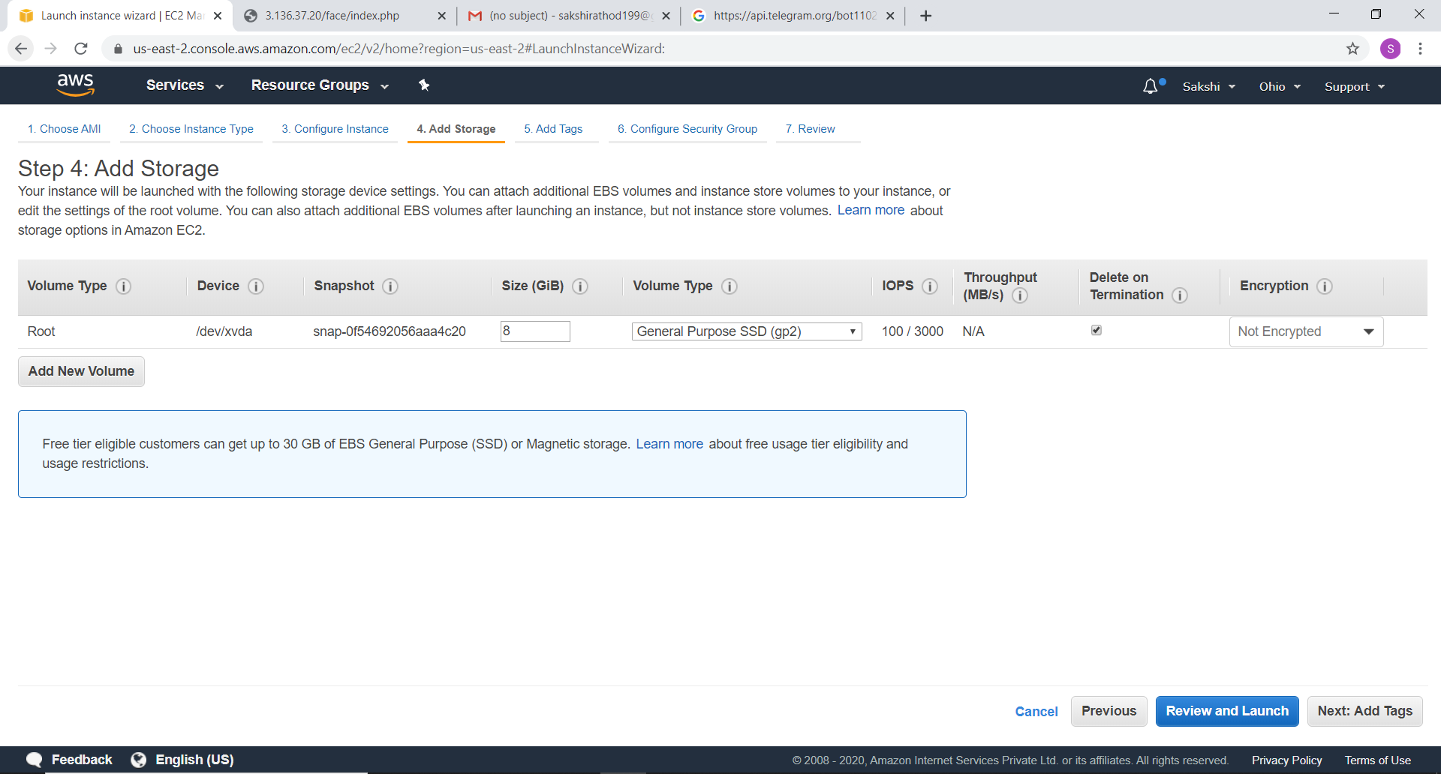 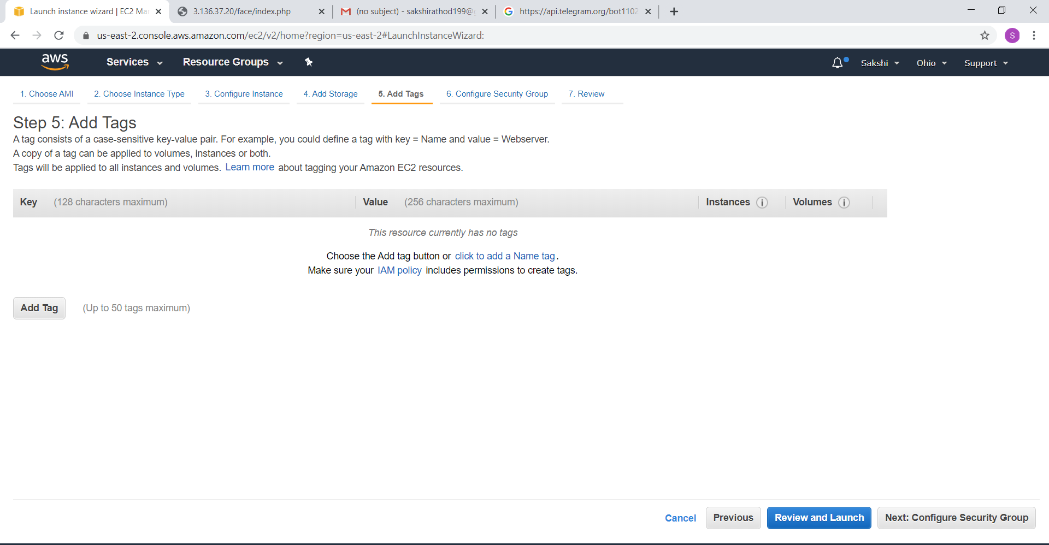

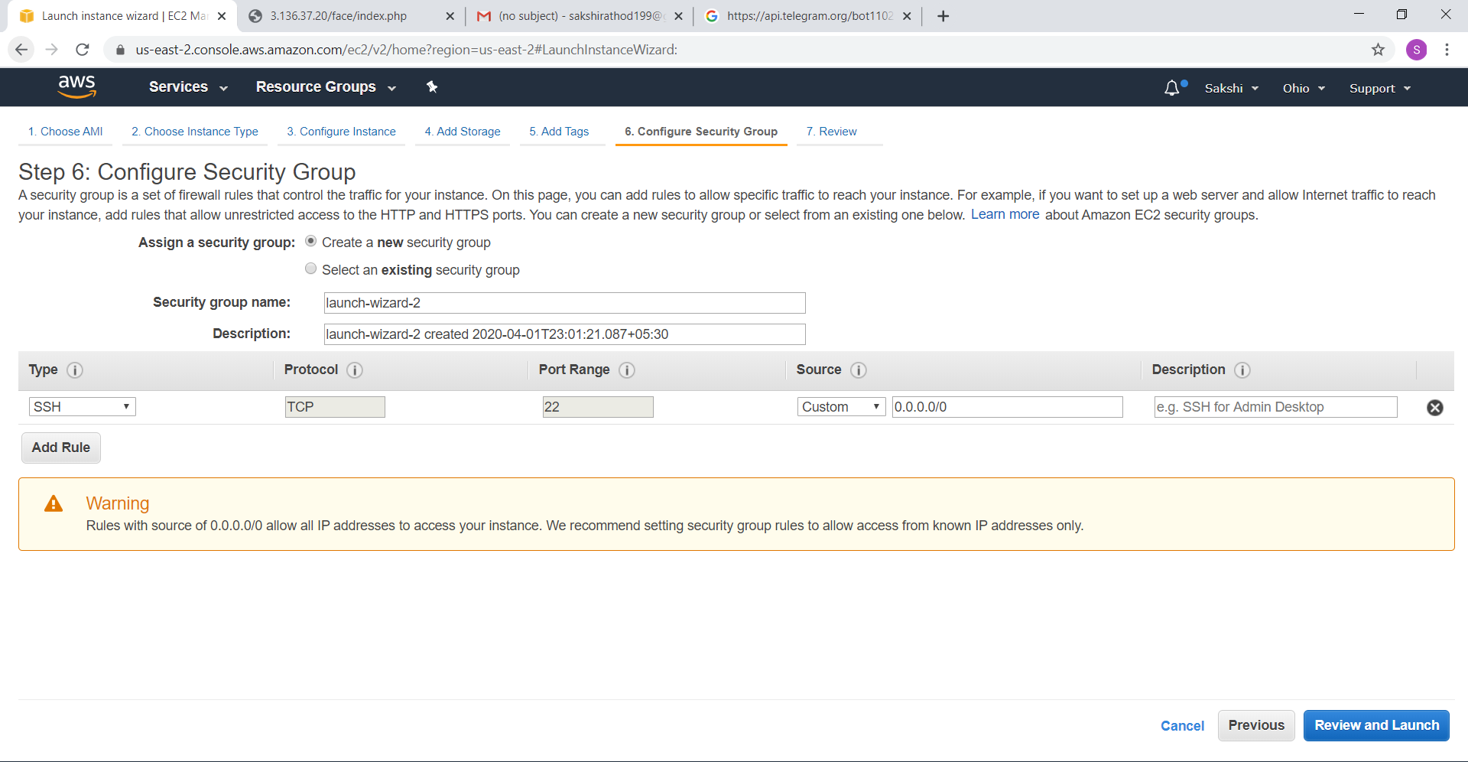

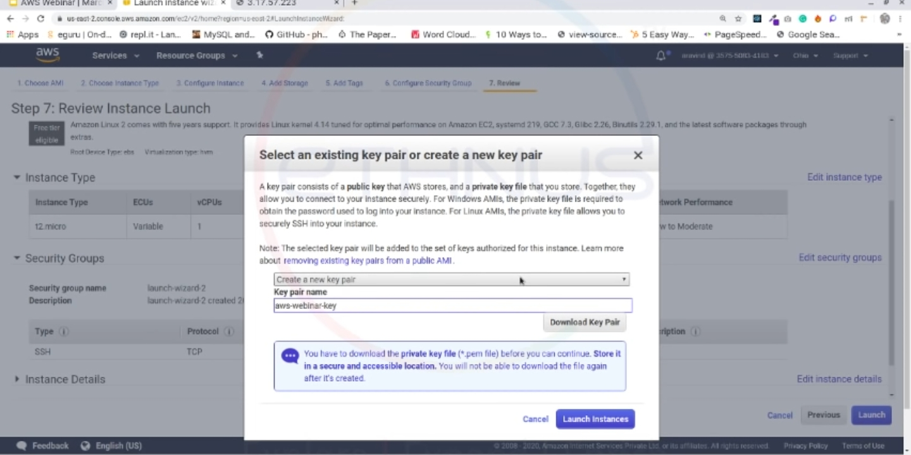

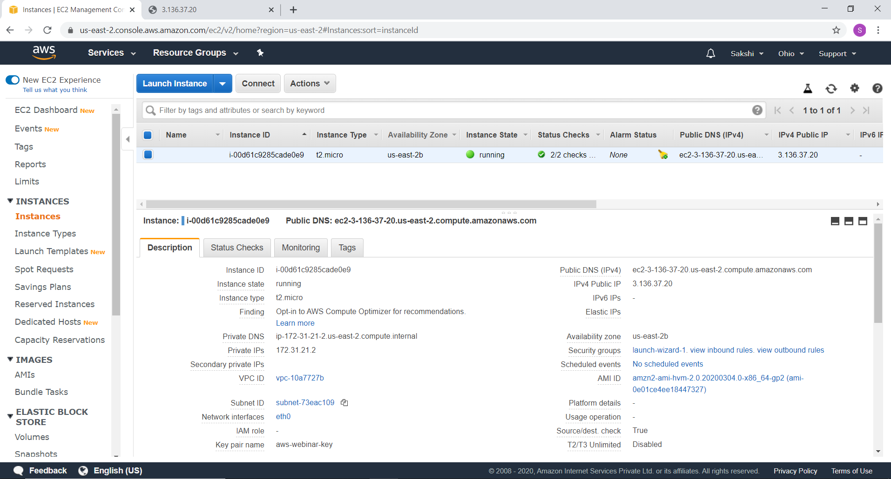

How do we connect to instance?

It’s a Linux based instance. So for connecting to this instance we need software called **putty**.

* Using putty we will connect to instance port 22 – ssh.
* First of all convert .pem to .ppk using **puttygen** or command (puttygen keyfile.pem –o keyfile.ppk).
* Now, login to Ec2 using putty.
* Configure your putty session. Click session. In host name, paste the public IP address copied from your EC2 instance description screen.
* The connection list, expand SSH. Click Auth. Browse to and select the .ppk file that you downloaded.
* Click open to select it. When prompted login as, enter ***ec2-user*** & press enter. This will connect to your EC2 instance.

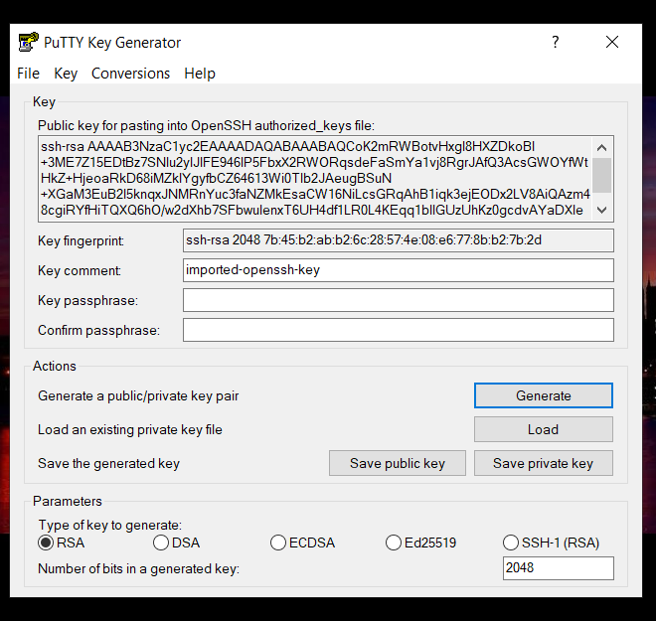

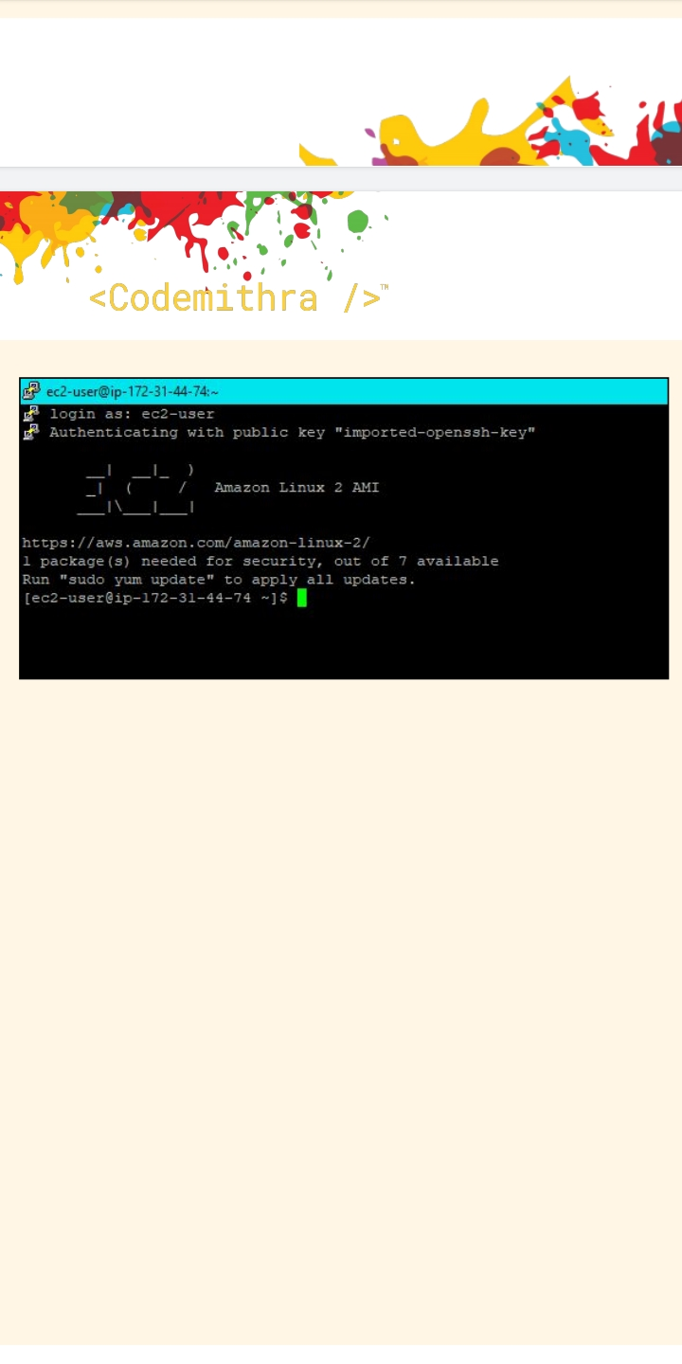

Let’s install a server(Apache/HTTP server):

* **sudo yum install httpd** (download & install particular service)
* **sudo service httpd start** (To start the service)
* **sudo service httpd status** (To check the status)
* **sudo vim /var/www/html/index.html**

Press enter then press i. Now, write whatever you want. Once finish:-

Esc :wq (hit an enter)

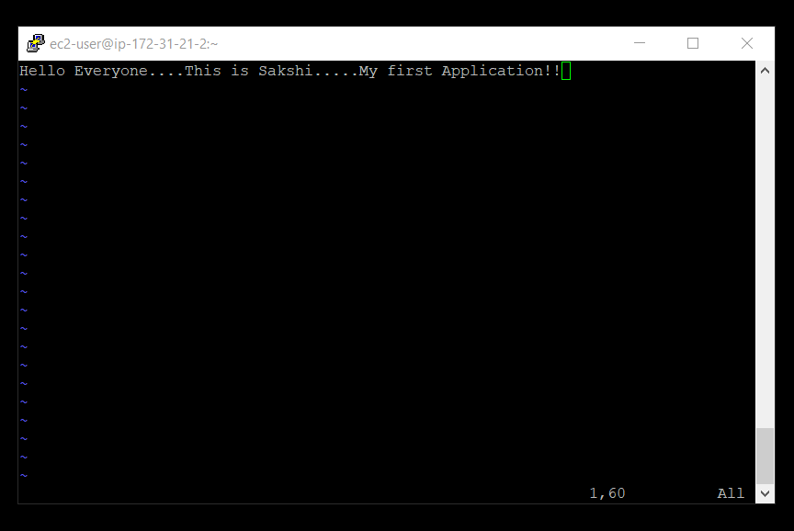

To add http in security group:

* Go to security group then click on launch wizard.
* Click on security group id & go to edit inbound rules.
* Add rules 🡪 HTTP source: anywhere

**Finally, copy IPv4 public IP & paste on browser:**

**S3:**

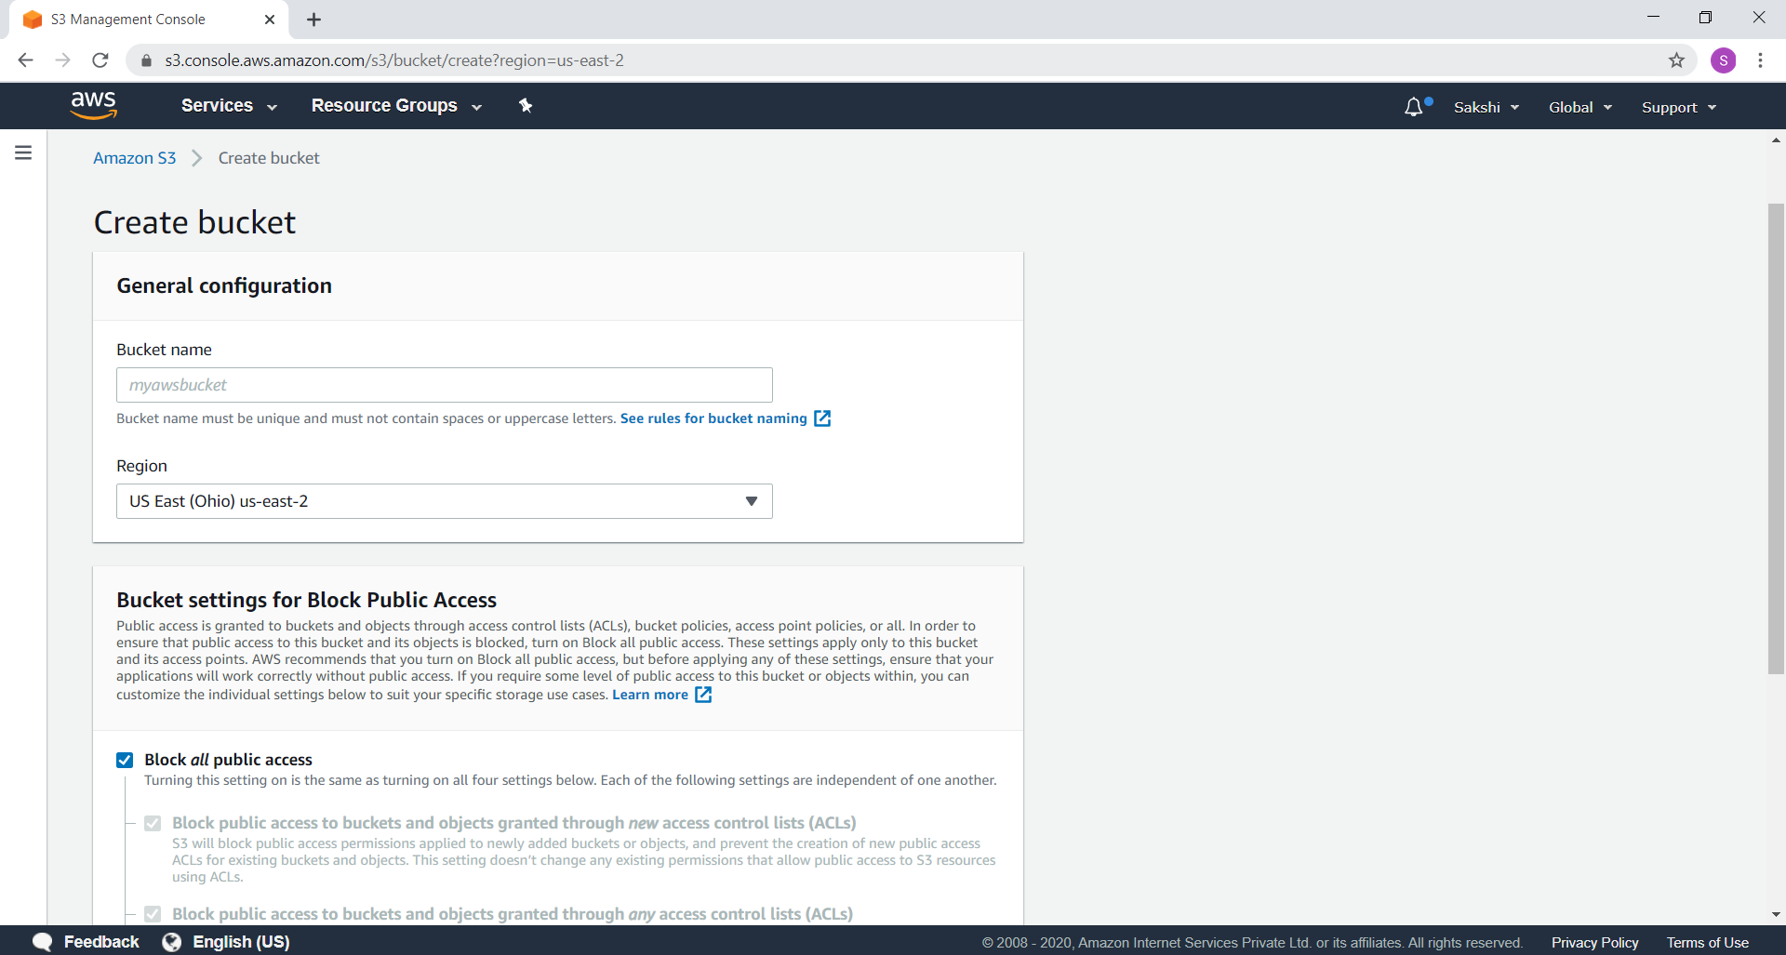

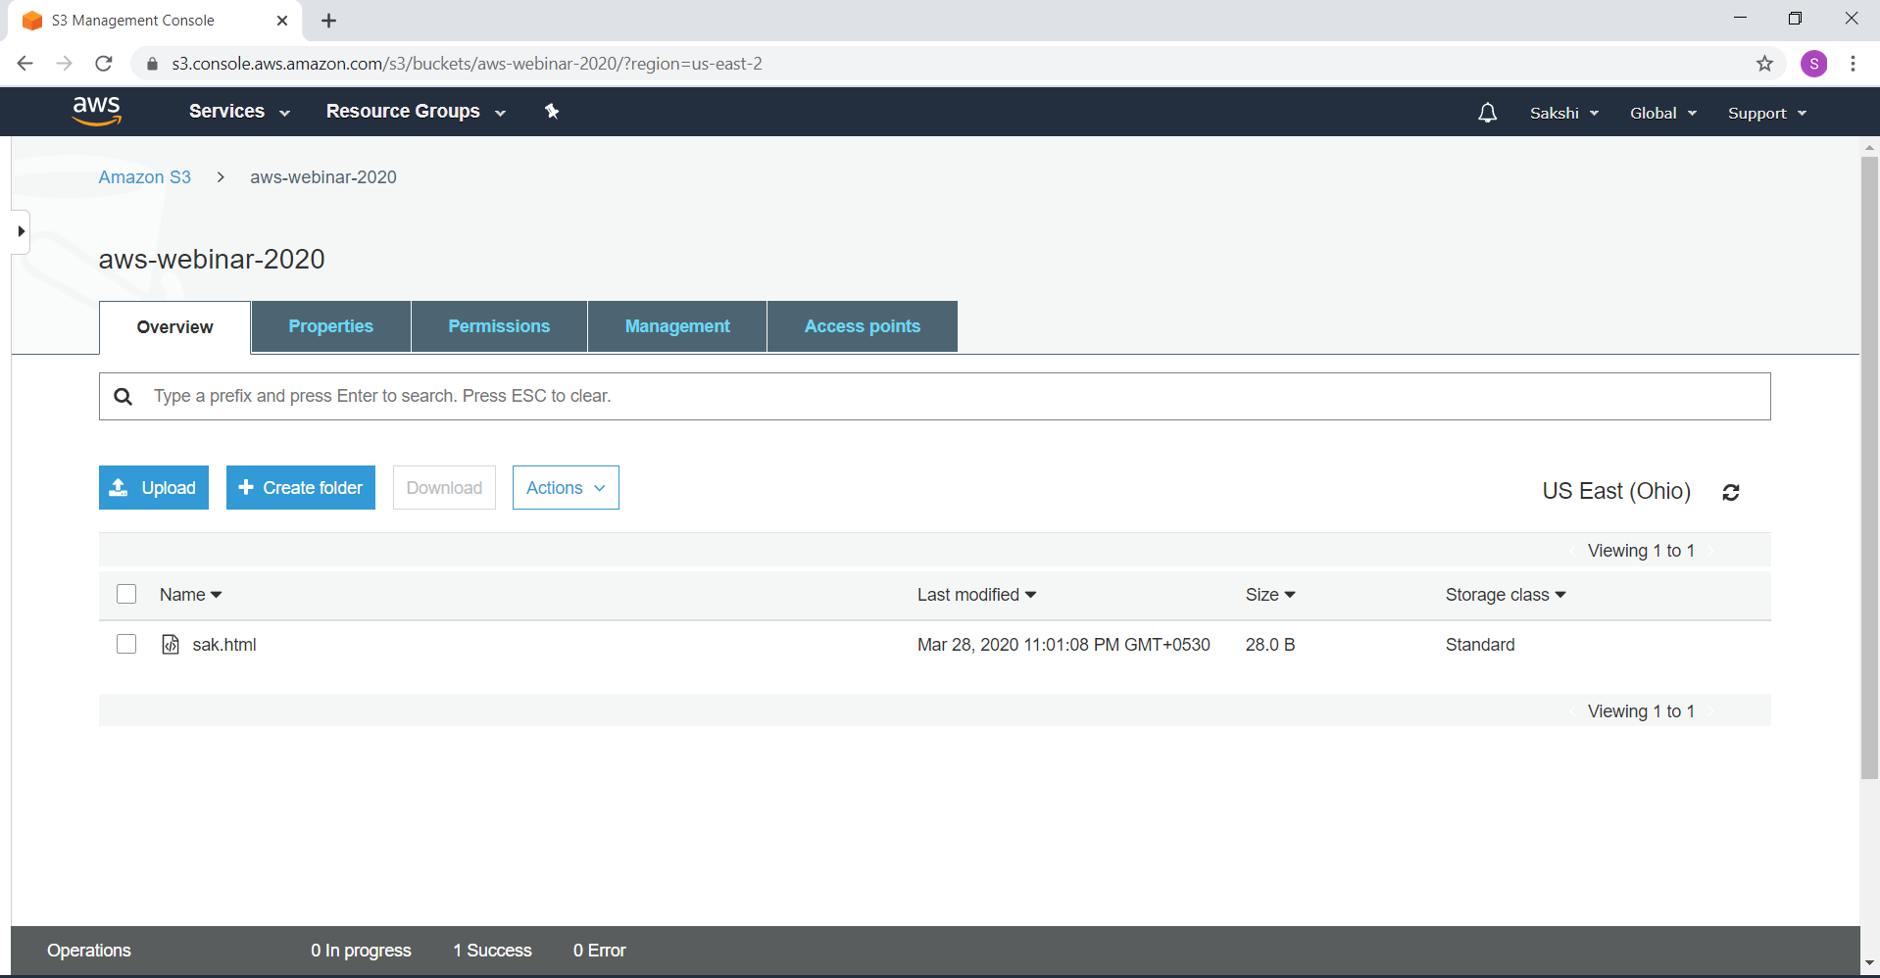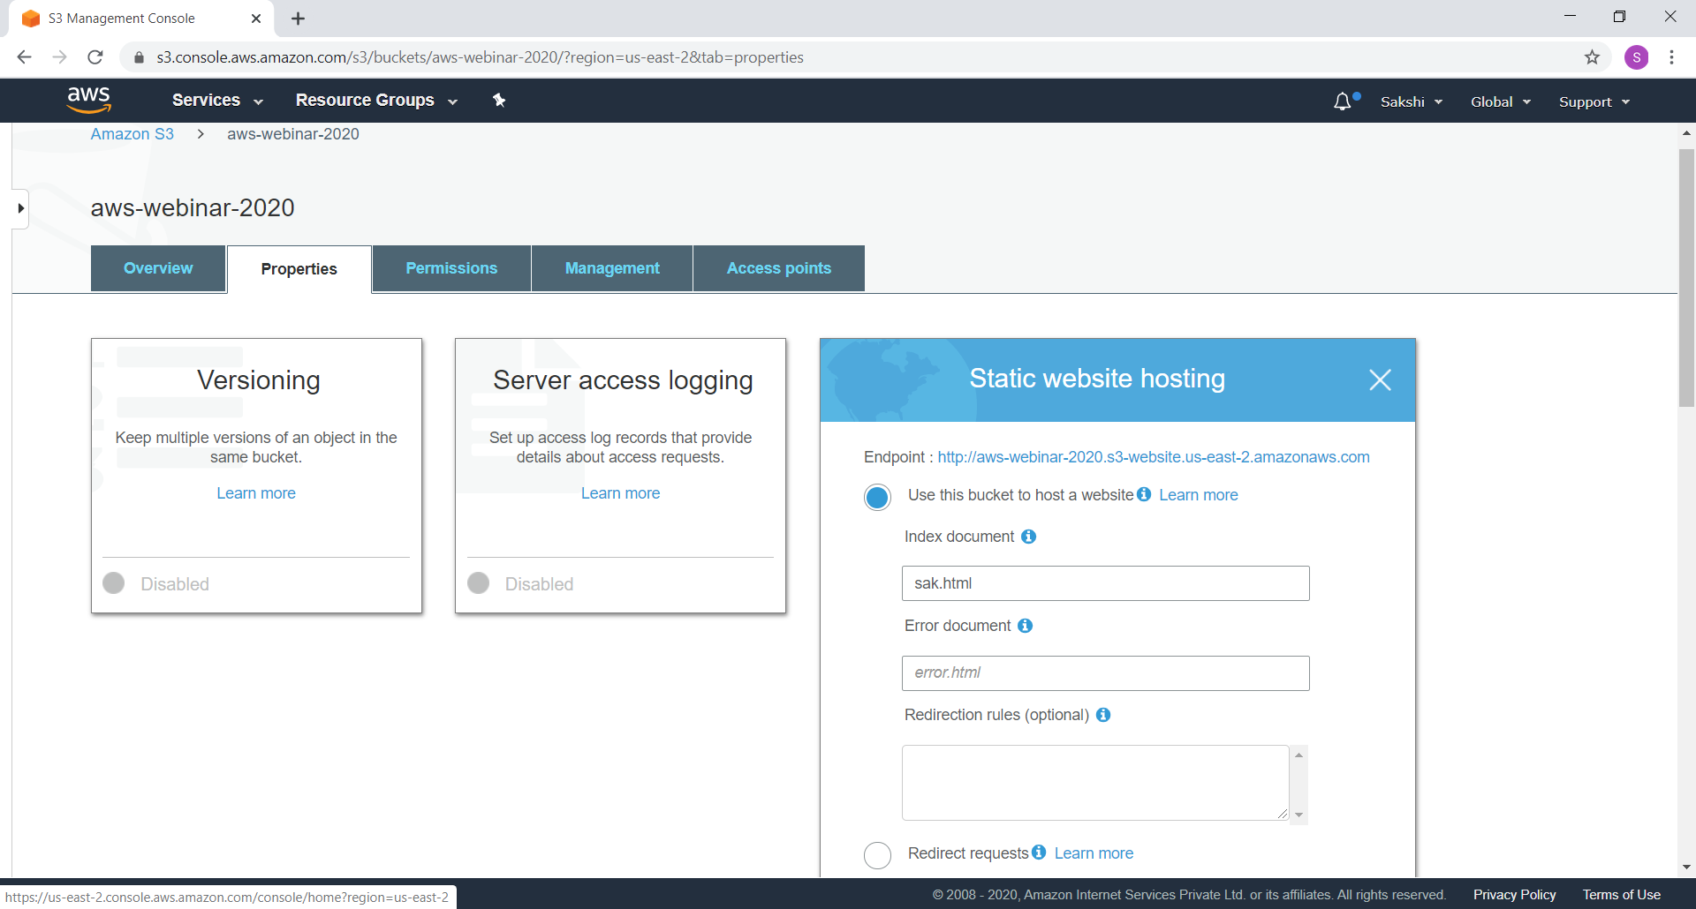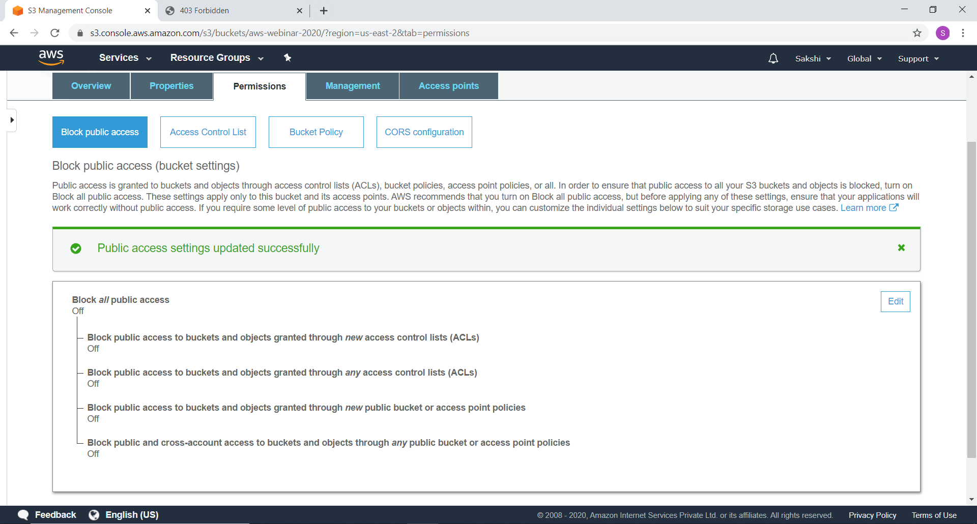



**Recognition:**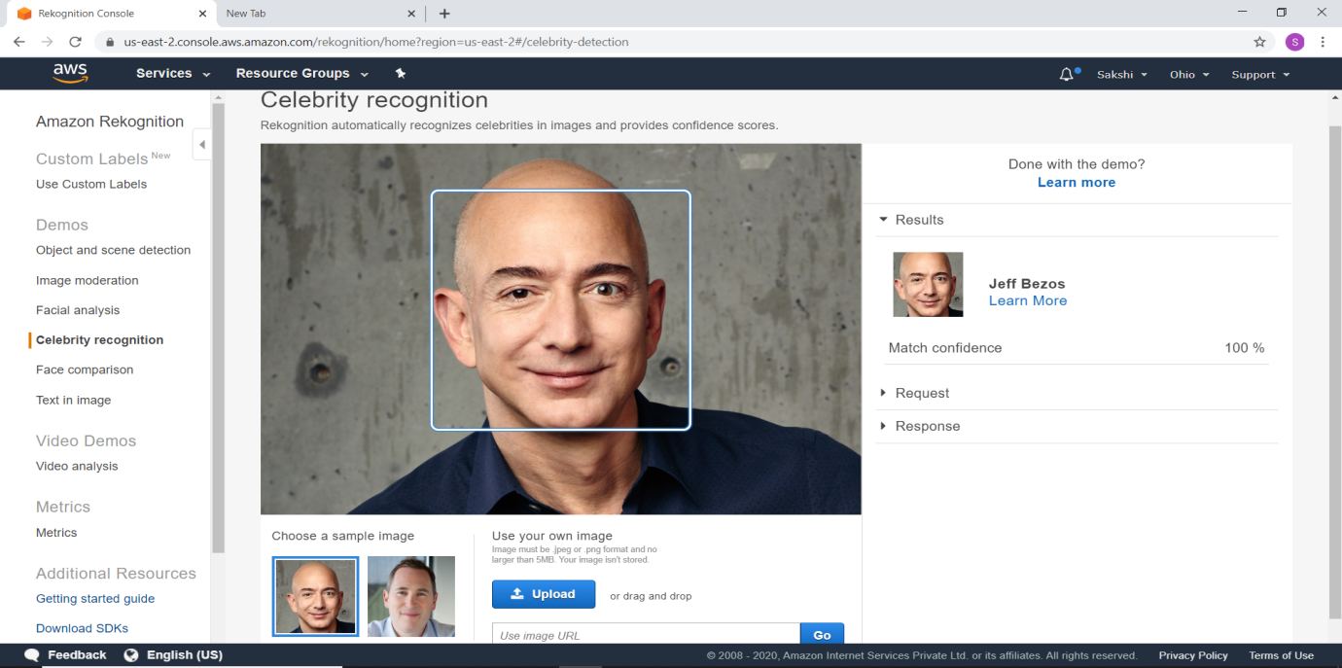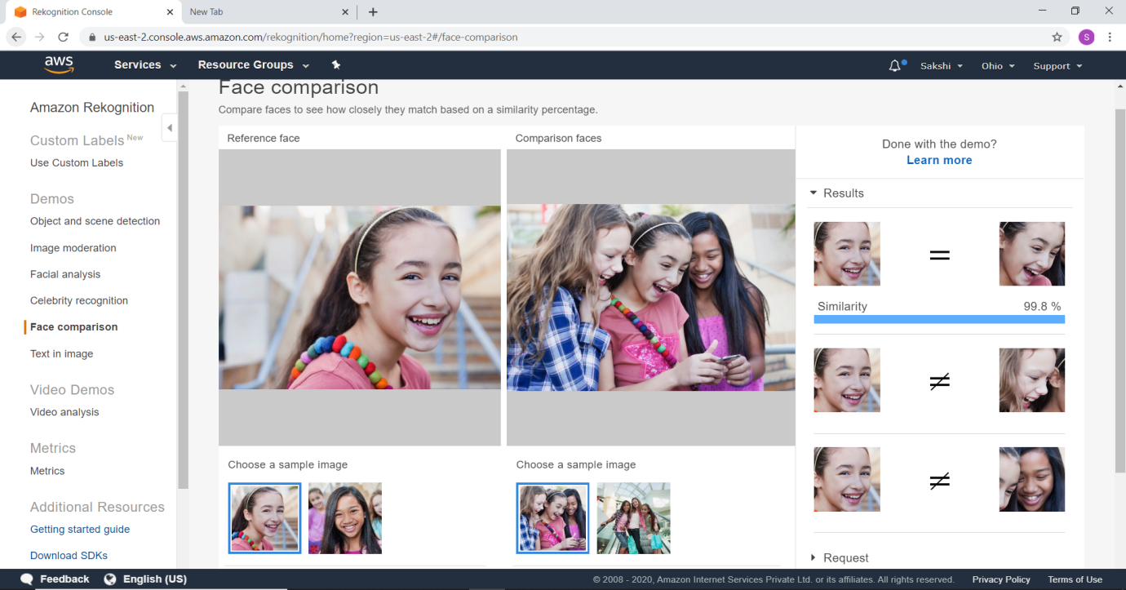

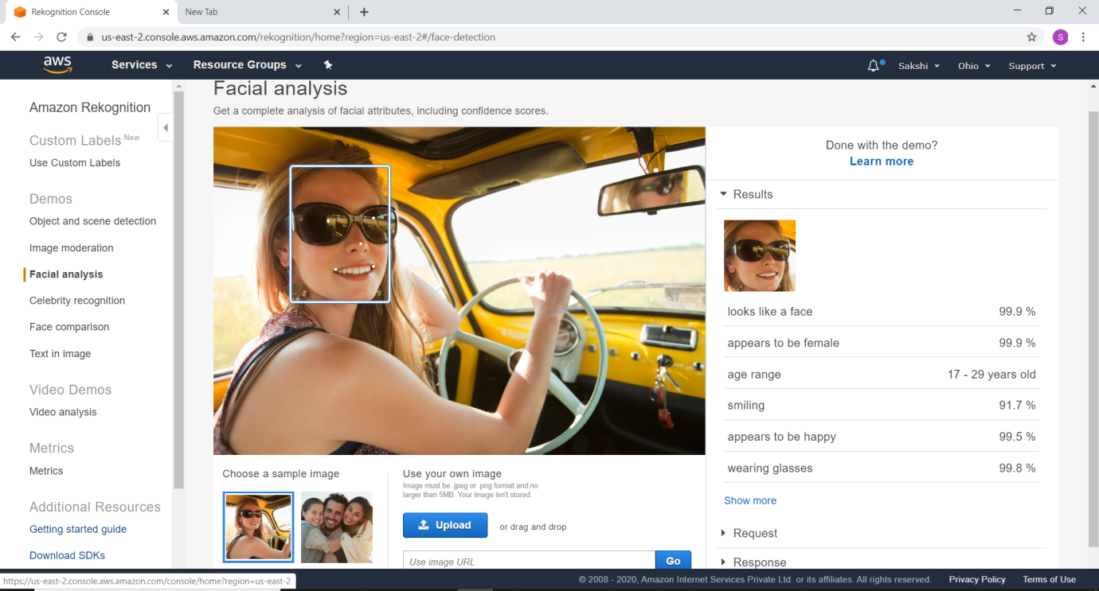



**EC2 and S3:**